An Immersive Virtual World in Unity

# Claustrophobia Simulator

## Introduction

Virtual Reality has been a focused area of research for many years. With the release of some advanced tech VR headsets later this year such as the Oculus Rift [1] and Vive [2] the demand for further development in VR technology is dramatically increasing. Currently VR has been used to create some innovative practical VR applications such as Virtual theatres for Doctors to practice critical surgeries or simulated environments to diagnose and treat phobias and illnesses [3].

This assignment extends the learning materials and academic competencies taught on the SE3VR11 Virtual Reality course at the University of Reading [4]. It investigates the practicalities of using virtual reality to build applications that deliver an interactive virtual environment, scene object etc.

## Background/Motivation

In order to further absorb and reinforce the course content delivered on the SE3VR11 module two assignments are to be completed. The first was an Individual assignment to design and implement a virtual world in Unity. This is initially to familiarise oneself with the Unity editor tools and explore the mechanisms that allow a user to interact within a realistic virtual world. The first assignment was satisfied with a virtual two storey house incorporating windows, interactive doors and light switches. Textures, materials and models are also used to increase the believability and immersion of the world [4]. This assignment investigates the practicalities of an immersive virtual reality application through completion of a group project. Each of the members is expected to contribute to the design and development of a virtual world that is utilitarian, immersive and realistic. The members are then to document their contribution towards the project by discussing the projects objectives, how their work contributed towards the project aims and how and if they were satisfied.

## Design/Requirements Analysis

The team discussed the possible applications that could be developed and there purposes. After researching current VR applications and simulations a conceptual design was reached. The team concluded on a claustrophobia simulator to allow a user to experience, manage and train claustrophobia symptoms by introducing features and triggers into the world that trigger symptoms of the phobia. The proposed environment would be comprised of four zones which would introduce features and scenarios that replicate real world common challenges a claustrophobic person may encounter in the world today such as elevators, revolving doors small cupboards etc. There would also be a comfortable starting area. The concept here is that each zone would become more of a challenge by introducing harder tasks to overcome and magnifying triggers in the environment. For example the last zone is located in the basement where there are no windows, very narrow hallways and small rooms compared to the Zone 1 which has wide hallways and fair size rooms. Aspects such as time constraints and team member numbers also dictated the design and concepts that could be proposed. This environment built up of zones essentially serves as the training or diagnostic suite for the application and then a separate environment would host a resizing/shrinking room that serves as a test suite. This is so that the user would be able measure there progression in some form from the training scene. Depending on the progression of the project other features such as a point scoring system for areas entered and features interacted with may be implemented. Figure 1 below shows the designed floor plan by the team.

**Figure.1 Floor plan design**

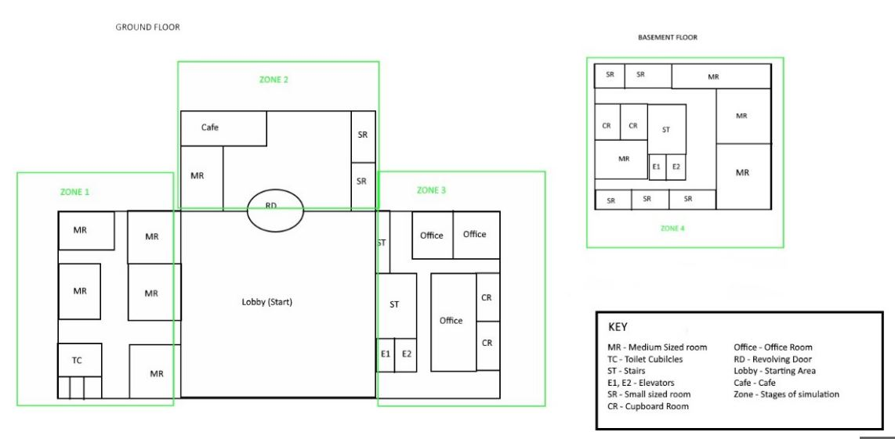

## Implementation

This report documents the development of Zone 3 in the simulator and illustrated in figure 1 floor plan. Zone 3’s main feature is the elevator, a common trigger for claustrophobia []. Considerations for the area being one of the last zones is taken into account where the size of the rooms are smaller, there is less lighting and more challenges incorporated in a smaller space.

**Figure.2 Screen Shot of Zone 3**

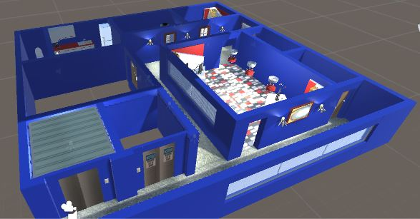

## Testing

Object Collision Tests

Feature Interaction Tests

* Elevator

If the elevator buttons are pressed continuously throughout the animation being played then the interior and exterior doors and the elevator start to operate out of synch. This can be fixed with some error handling that will prevent the user clicking more than once until animation has finished playing or an amount of time has passed.

Rendering and Smoothness

In each of the

## Results

What aspects of the project where met.

## Discussion

The program was very large and demanding on computer resources when running.

Other deadline priorities, time management, team communication. Team congregation

## Further Work

Correct and perfecting the elevator would be an aim.

Applting physics to the chairs. Interaction with fridge

The main two aspects referred to with claustrophobia is the feeling of restriction and suffercation

If a heart rate receiver from something as common as a smart phone could input readings from a user into the environment then even more interactive control and immersive reality can be achieved.

## References

[1] ref to VR module

[2] ref to previous individual coursework

[] Common trigger for claustrophobia, Phobias.com. Available at: <http://phobias.about.com/od/phobiasatoh/f/What-Is-The-Fear-Of-Elevators.htm>